

**FACULTY:** Information Technology

**COURSE:** Multivariable Calculus and Differential Equations

**COURSE CODE:** MATH8213

**ACADEMIC YEAR:** 2025 – 2026

**TEAM: 1**

**VENUE :** Gishushu Campus

**LECTURER:** NIZEYIMANA Viateur

**SEMESTER : 1**

|  |  |  |  |
| --- | --- | --- | --- |
| ID | Names | Date of Meeting | Signature |
| 26432 | Ntaganira Habimana Happy (Chief) | 10/08/2025 |  |
| 24122 | Mukama Yves Thomas | 10/08/2025 |  |
| 24673 | Kambale Kiregha Ezechiel (Sec) | 10/08/2025 |  |
| 24889 | Bideri Alec | 10/08/2025 |  |
| 25051 | Mugiraneza Mugabo Octave | 10/08/2025 |  |
| 25234 | Ndeko Kaduli Jordan | 10/08/2025 |  |
| 26233 | Jarwin W Monboe | 10/08/2025 |  |
| 26317 | Ishimwe Bienvenu | 10/08/2025 |  |
| 26439 | Niyonkuru Arnold | 10/08/2025 |  |
| 26505 | Shema Jean Baptist | 10/08/2025 |  |
| 27354 | Munyaneza Manzi Sarto | 10/08/2025 |  |
| 27380 | Mushirarungu Ghislaine | 10/08/2025 |  |
| 27388 | Bakwiye Massa Patience | 10/08/2025 |  |
| 27404 | Uwera Cynthia Carmella | 10/08/2025 |  |
| 27409 | Teta Allen | 10/08/2025 |  |
| 28236 | Ineza Semuhungu Joel | 10/08/2025 |  |
| 28240 | Rukimirana Olivier | 10/08/2025 |  |
| 29061 | Mutangana Joseph | 10/08/2025 |  |
| 26314 | Nishimwe Diane | 10/08/2025 |  |

**Q1**.In 2D affine space endowed with orthonormal frame, given a triangle with vertices

**C)**

In **mx** = x is any value

4

i)

=7.95

**5.**

Intersect with x=1:

y=1.5−2(1+1)=−2.5

**Incircle :**

inradius r = area / s = 1.2721

incenter = (-1.3886, 2.7279)

incircle area = 5.0837

incircle perimeter = 7.9927

**Circumcircle :**

circumcenter = (1.0, -2.5)

circumradius R = 7.1589

circumcircle area = 161.0066

circumcircle perimeter = 44.9808

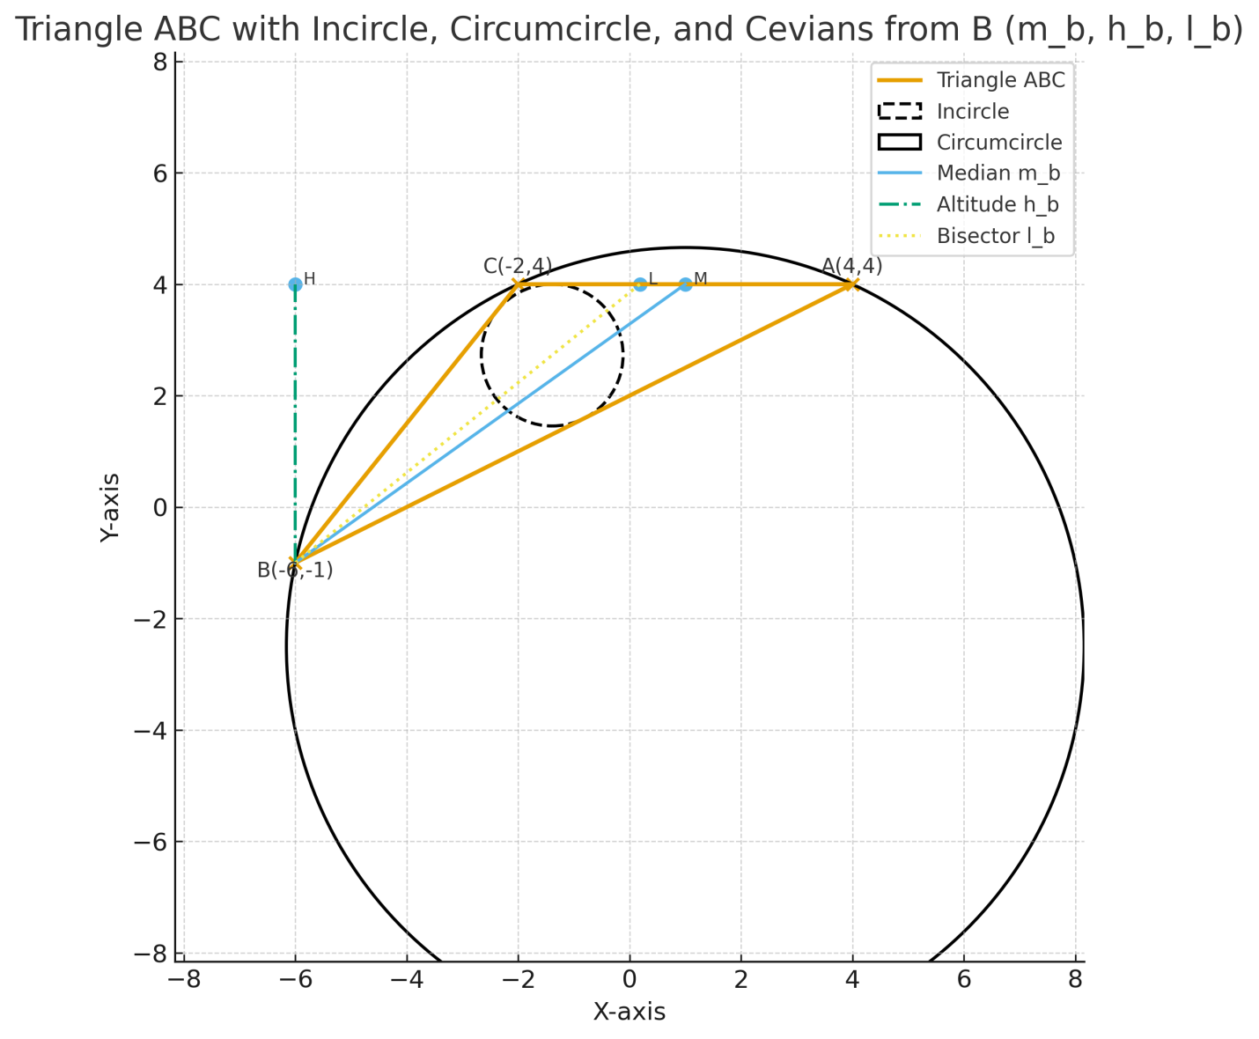

**Q2**. **In 3D Euclidean space equipped with orthonormal frame, given a tetrahedron with vertices**

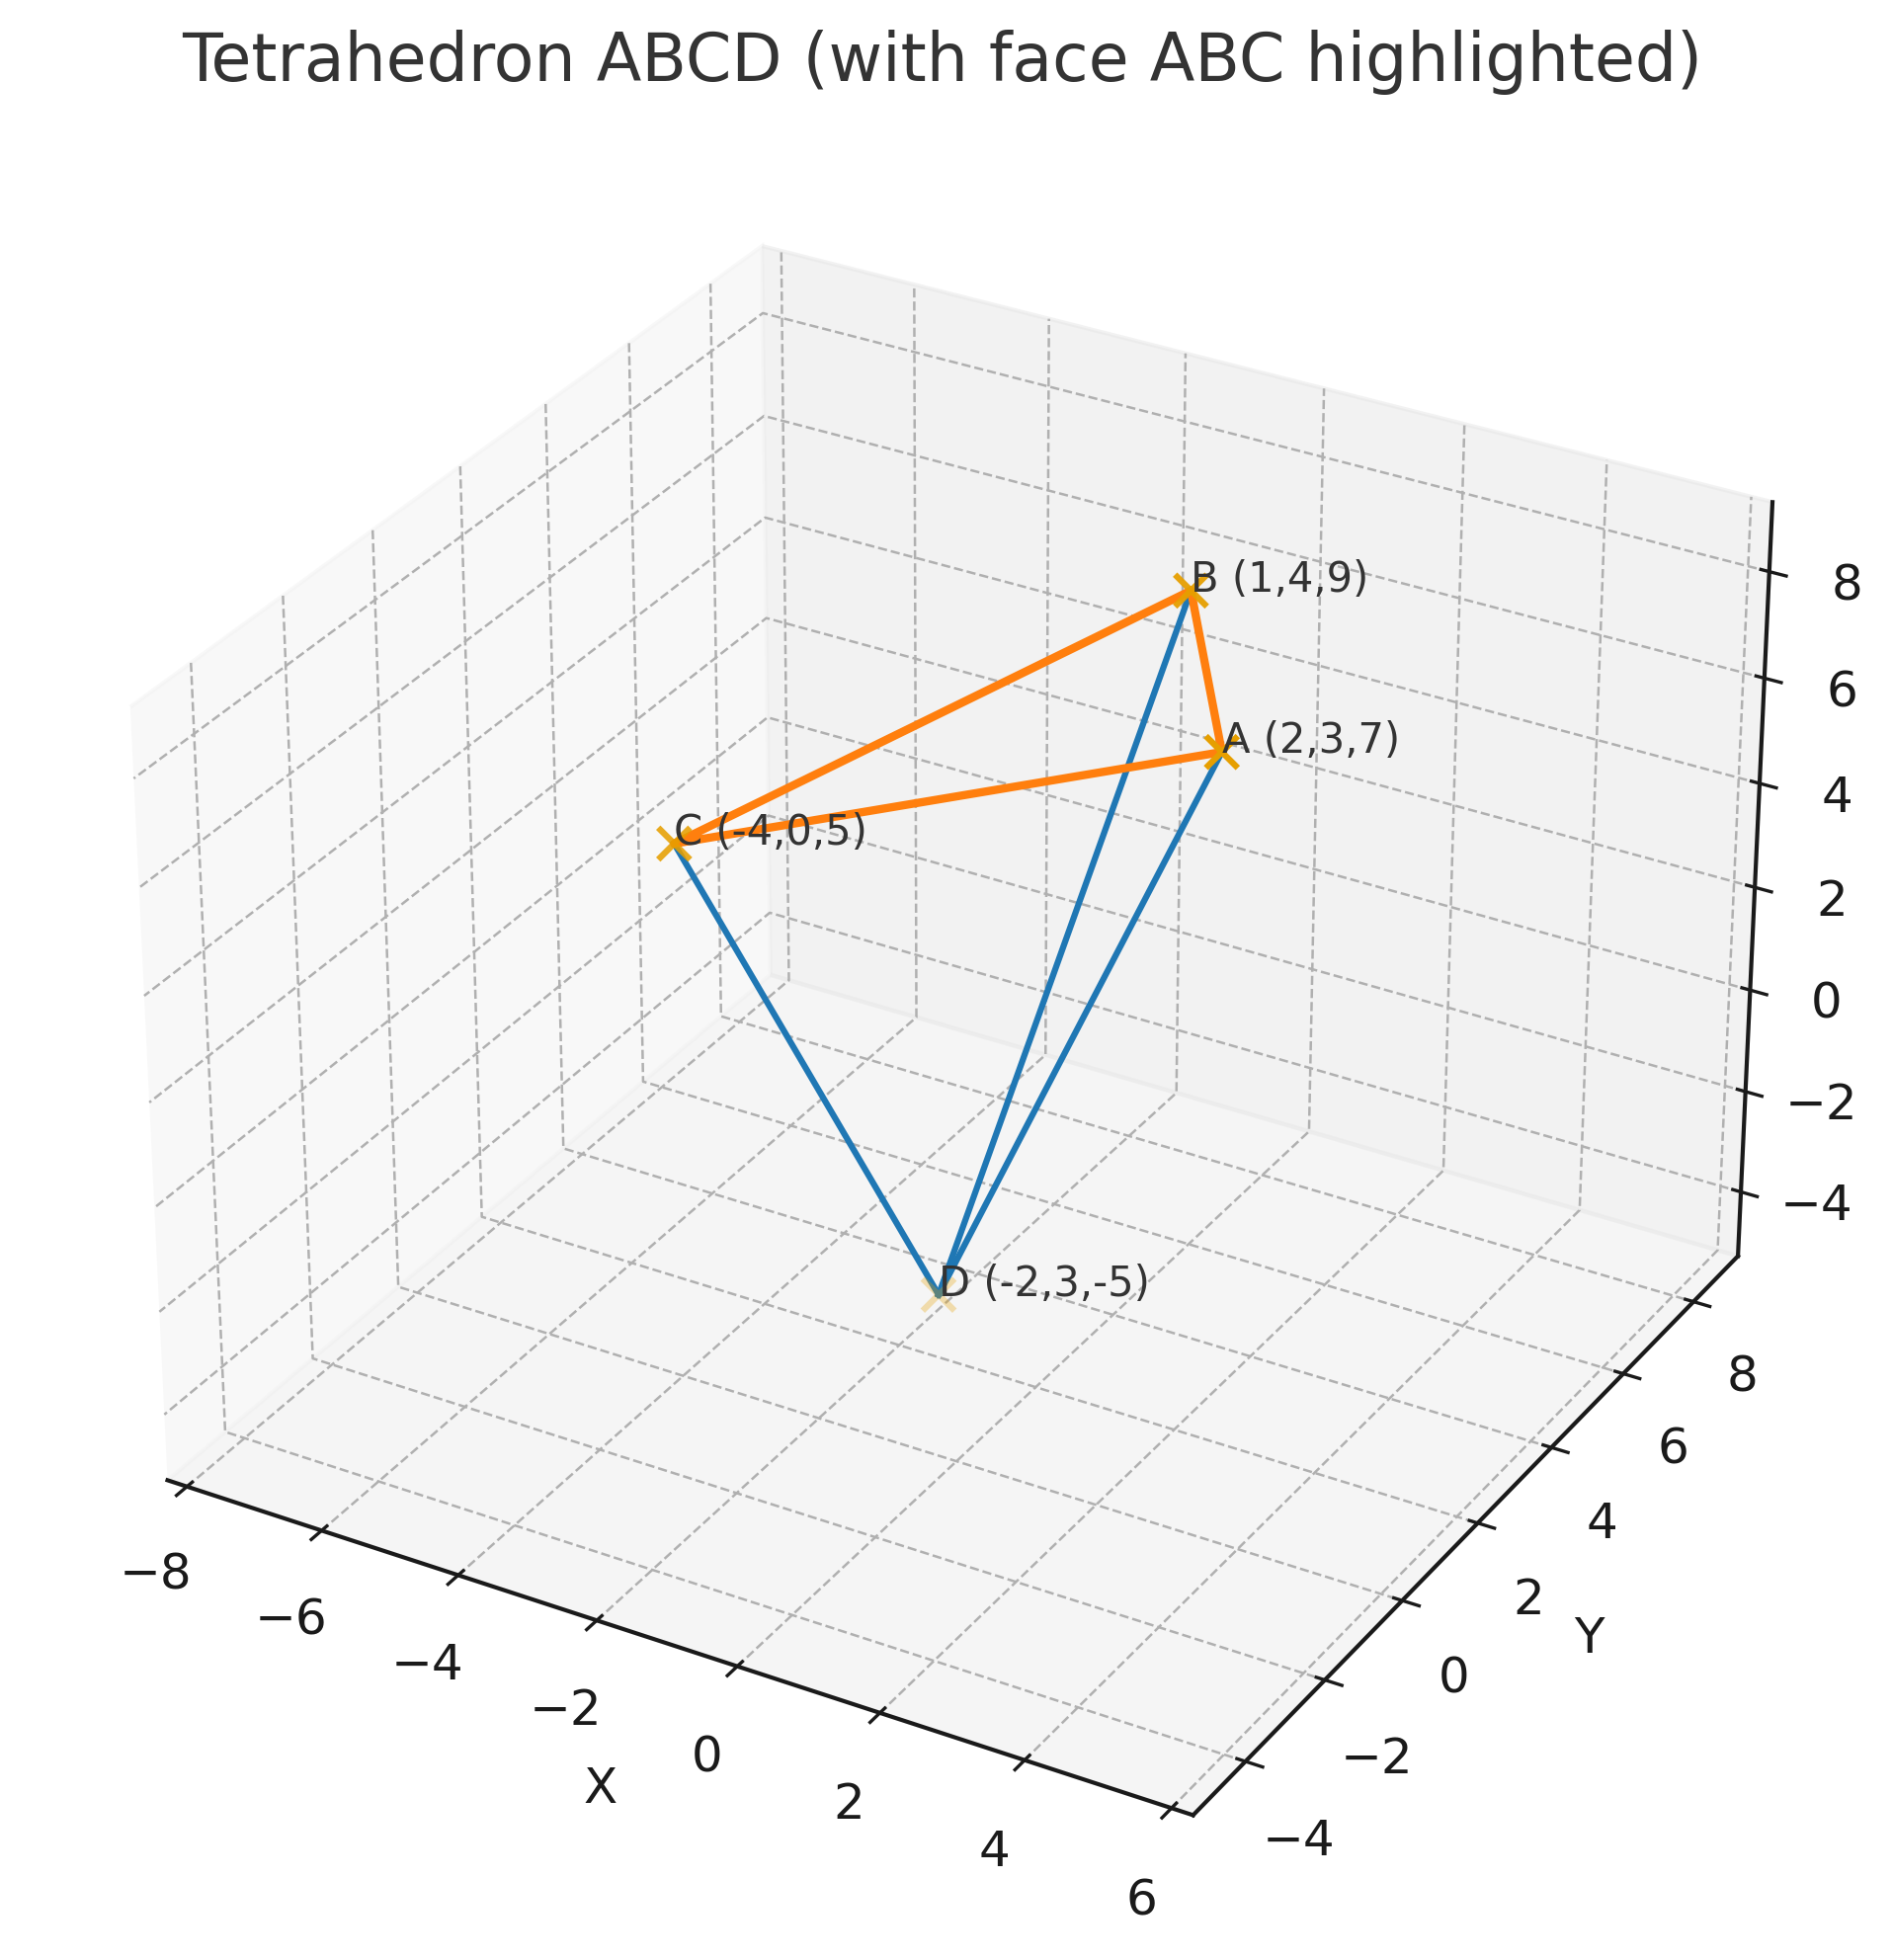

**Q3. The polar coordinates of the end points of the segment *AB* are:**

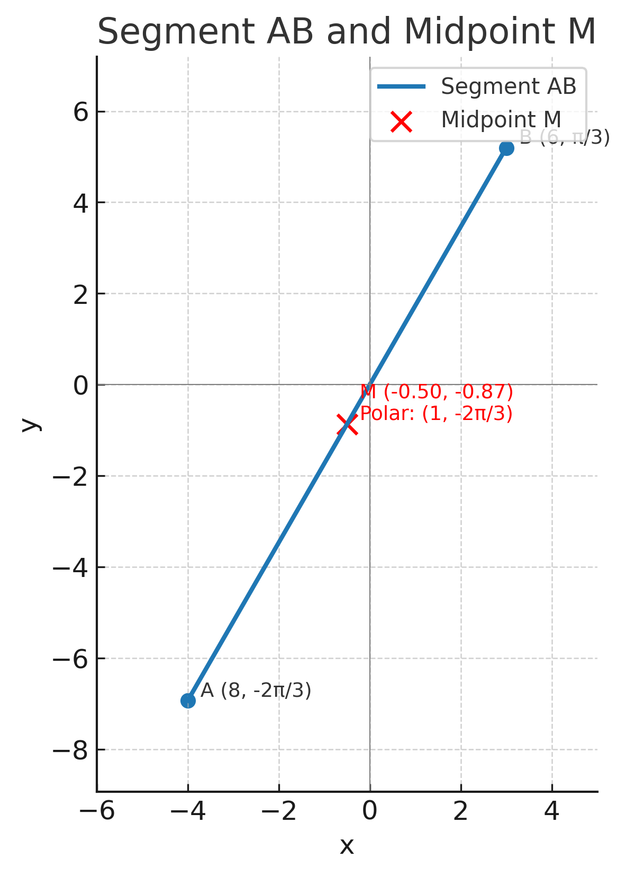

**Q4**. **Use 2D-Geogebra and plot on the same chart the graphs of the following 2d-curves expressed in polar coordinates.**

